# OCT Tehran Result

## VGG Model:

### Classification:

precision recall f1-score support

AMD 0.99 0.94 0.97 254

DME 0.96 0.99 0.97 173

NORMAL 0.97 1.00 0.98 212

accuracy 0.97 639

macro avg 0.97 0.98 0.97 639

weighted avg 0.97 0.97 0.97 639

### Accuracy and Loss Curve:

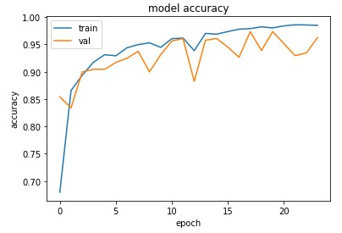

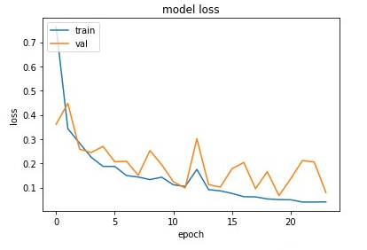

### Confusion Matrix:

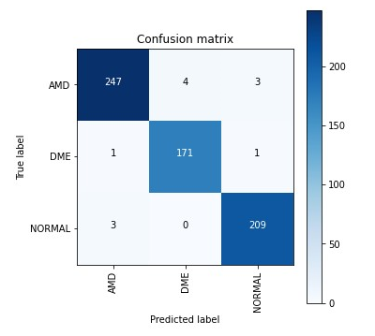

### ROC:

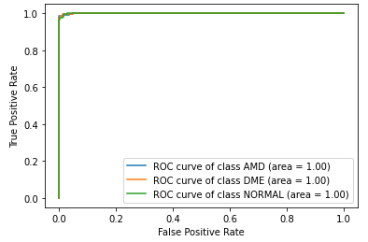

### Heatmap:

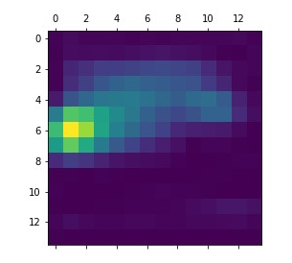

### Grandcam:

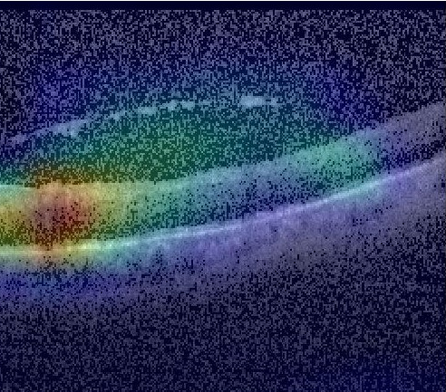

### Histogram:

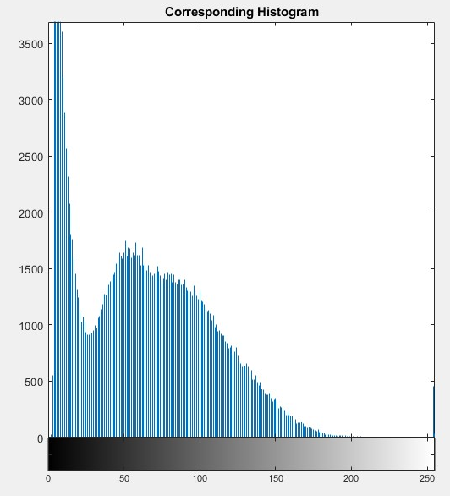

## Incresnet:

### Classification:

precision recall f1-score support

AMD 0.97 0.93 0.95 254

DME 0.97 0.89 0.93 173

NORMAL 0.89 0.99 0.93 212

accuracy 0.94 639

macro avg 0.94 0.94 0.94 639

weighted avg 0.94 0.94 0.94 639

### Accuracy and Loss Curve:

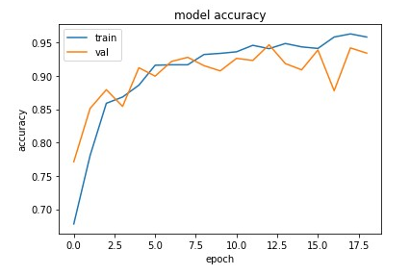

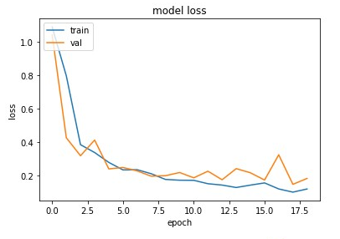

### Confusion Matrix:

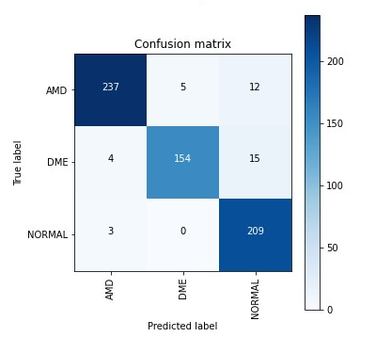

### ROC:

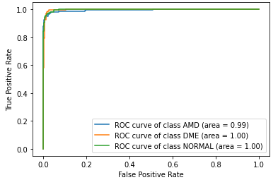

### Heatmap

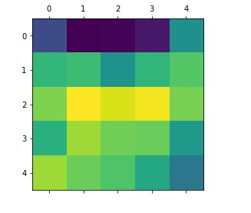

### Gradcam:

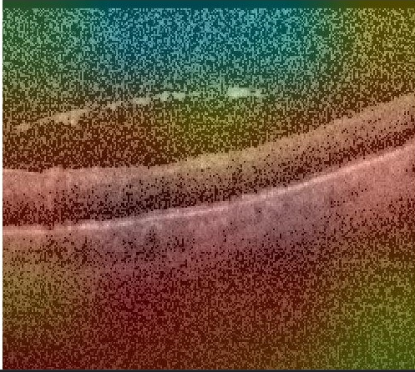

### Histogram:

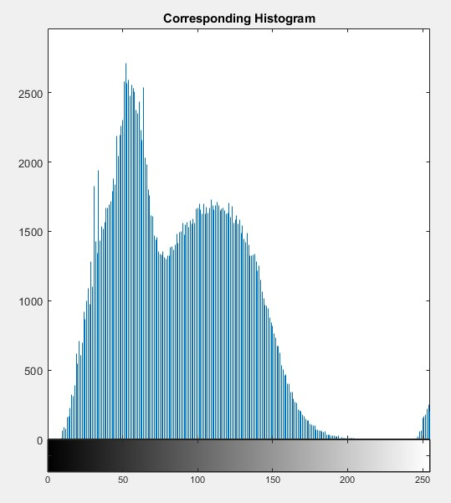

## Custom Model:

### Classification:

precision recall f1-score support

AMD 0.97 0.96 0.96 254

DME 0.95 0.99 0.97 157

NORMAL 0.97 0.96 0.96 228

accuracy 0.96 639

macro avg 0.96 0.97 0.96 639

weighted avg 0.96 0.96 0.96 639

### Accuracy and Loss Curve:

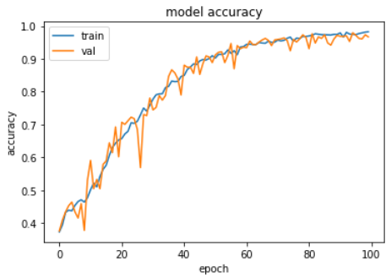

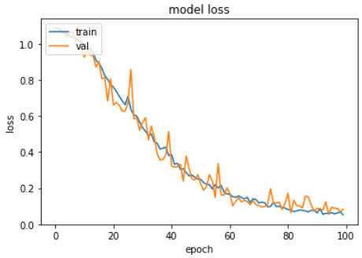

### Confusion Matrix:

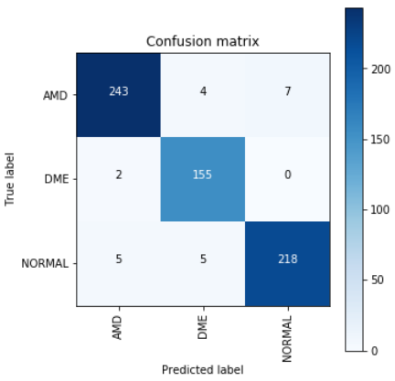A

### ROC:

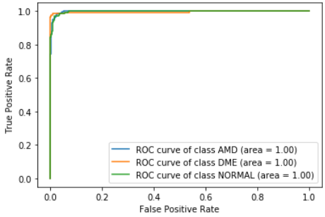

### Heatmap:

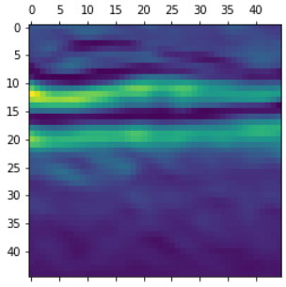

### Grandcam:

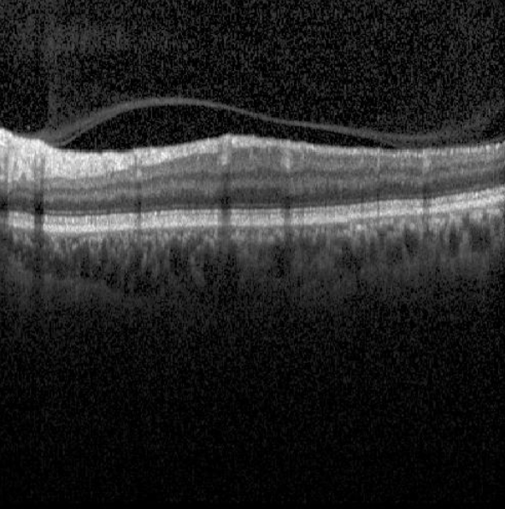

Histogram:

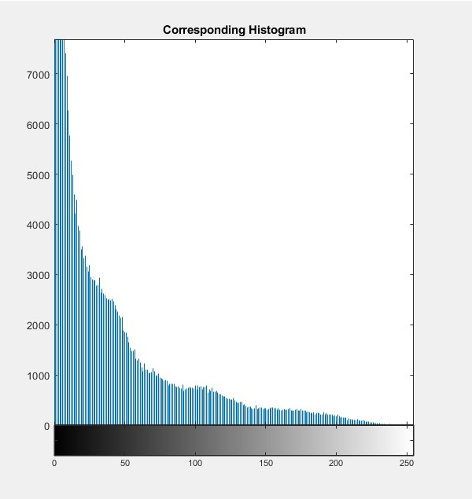

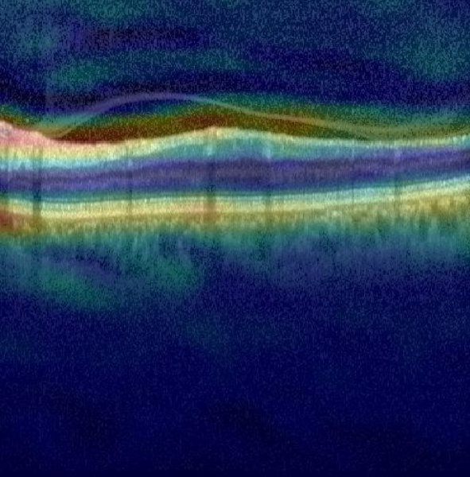

### Histogram:

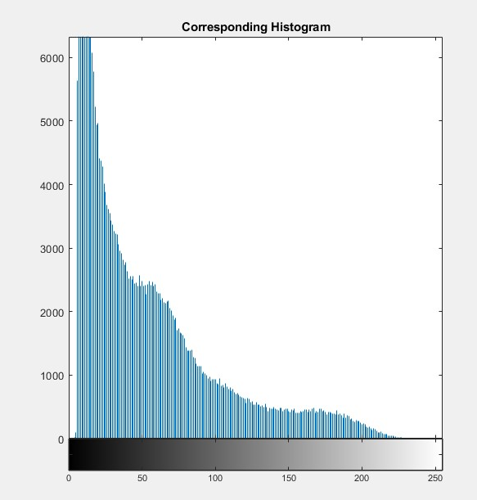

## Inception Model:

### Classification:

precision recall f1-score support

AMD 0.96 0.96 0.96 254

DME 0.94 0.97 0.95 173

NORMAL 0.97 0.95 0.96 212

accuracy 0.96 639

macro avg 0.96 0.96 0.96 639

weighted avg 0.96 0.96 0.96 639

### Accuracy and loss curve:

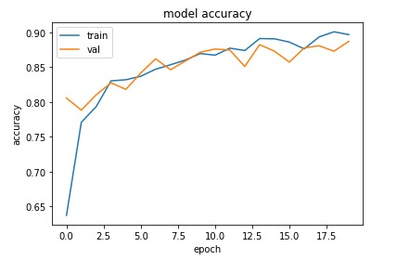

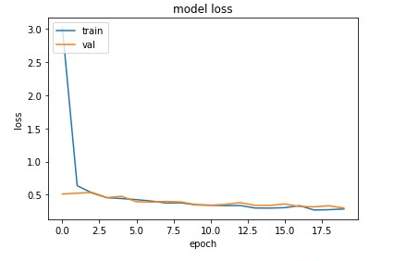

### Confusion Matrix:

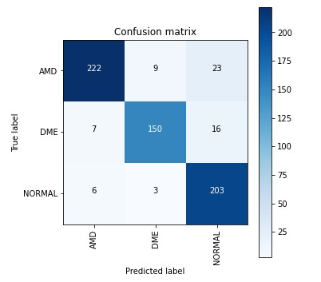

### ROC:

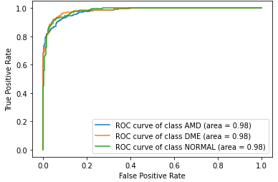

### Heatmap:

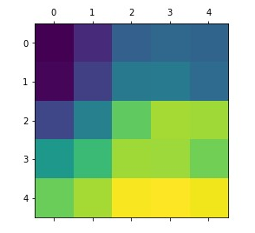

### Gradcam:

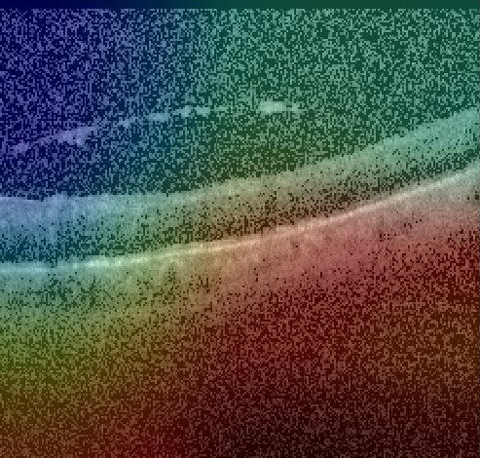

### Histogram:

